This project must be done in groups of 2 or 3 students.
Using code already provided, write functions that will move a mouse around a maze in search of the exit, eating cheese along the way. The compiled program will look as displayed below.
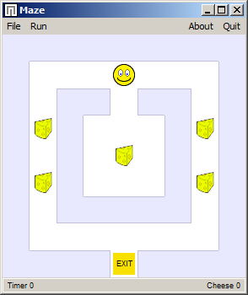
Download the following files and create a workspace using them:
https://www.msu.edu/~bowmanm/231/Program08.zip
- Program08.sln, Program08.vcxproj, Program08.vcxproj.filters
- Program08.cpp
- Maze Library.lib, Images.dll
- Maze 01.txt, Maze 02.txt, Maze 03.txt
This program is a Windows executable, not a command-line program. The graphics and user interface have been designed for you and are included in Maze Library.lib and Images.dll. You will need to compile the program using the Microsoft Visual Studio.
The zip file also includes three text files that contain maze maps to test your program.

The mouse maze is stored as a two-dimensional array of cells. A cell has the following values:
CELL_OPEN Open space – the mouse can move here.
CELL_WALL Wall – the mouse can’t move here.
CELL_CHEESE Open space with cheese. After moving the mouse here, the cell changes to CELL_OPEN.
CELL_EXIT The exit of the maze
You are provided two functions, which are called by the program when it runs:
void mouse_init(int x,int y) This is called when a maze map is loaded.
void mouse_move() This is called each tick of the internal timer.
When you select a maze file, the program calls mouse_init(). You are provided access to this function in case you need to initialize variables that are global to your Program08.cpp file.
When you start the mouse (select a speed from the Run drop-down), a timer begins. Every tick of the timer, the mouse_move() function is called. The sample provided only attempts to move the mouse at random. You will develop this function to make your mouse “smarter” as it searches for the exit.
Several helper functions are provided:
void mouse_look(cell map[3][3])
This function copies the cells surrounding the mouse from the internal map and places them in a 3x3 array. Your mouse is at position 1,1. Use this mini-map to determine which direction the mouse should move.
bool mouse_north()
bool mouse_south()
bool mouse_east()
bool mouse_west()
Each of these functions attempt to move in the direction indicated. If you attempt to move into a wall cell, the function will return false. The main program will only allow one move of the mouse each time the mouse_move() function is called.
int cheese_look()
This function returns the number of cheeses left in the maze.
Since time is limited, do not worry about perfecting your functions. Try to incorporate a simple decision making strategy, like don’t back up unless at a dead end, always turn left, or keep track of your last direction.

What to hand in
Hand in a paper copy of your Program08.cpp and Program08.h2 files. In addition, email a copy of those files to your instructor. Be prepared to demonstrate your program to the class with a discussion of the data structures and algorithms you implemented. Your code will be graded on its functionality, appearance, and comments.

